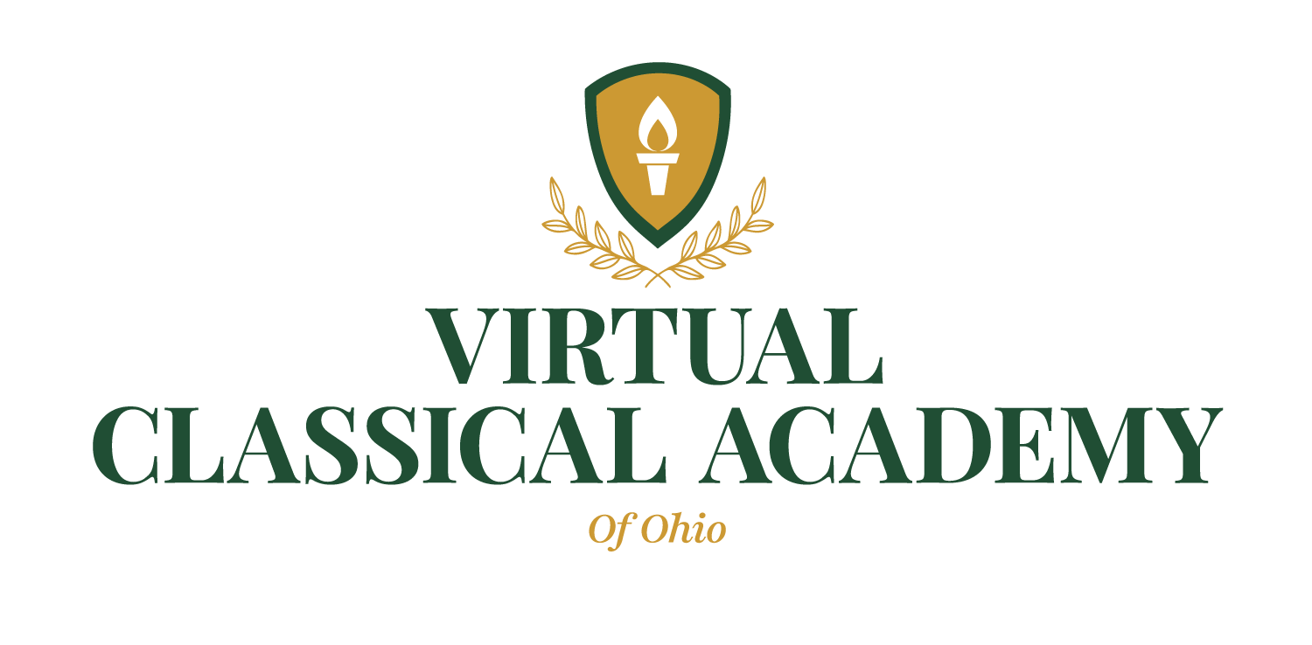

To: Parents and Guardians

Re: Parent/Guardian right to request the following information on the student's classroom teachers/paraprofessional

Parents and Guardians have the right to request the following from the school:

- Whether the teacher(s) have met the State qualification and licensing criteria for the grade levels/subject areas they are teaching.
- Whether the teacher(s) is teaching under any emergency or provisional status in which the State requirements have been waived.
- The undergraduate major of the teacher(s) and the area of study and any certificates for any graduate degrees earned.
- The qualifications of any paraprofessionals providing services to their child(ren).

